Let the games begin!
SOCHI, RUSSIA
WINTER PIANO OLYMPICS 2014
B I N G O
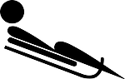  Finish 2 pages of Theory | Draw & color the Russian flag here: | Perform a short piece with your eyes closed. | Memorize one complete piece.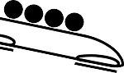 | Listen to a piece from “Peter and the Wolf” by Sergei Prokofiev.
Perform a piece for your family. 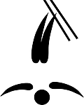 | Finish one unit of Sight Reading.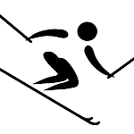 | Compose a piece that tells a story. | Learn 5 facts about the “Russian Five” to share at your next lesson! | 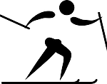  Pass off one technique key.
Compose a piece about Winter. | Pass off one technique key. | FREE  SPACE | Finish 2 pages of Theory. | Do 10 jumping jacks and then perform your piece with gusto!
Watch a ballet scene from “The Firebird” by Igor Stravinsky. | Memorize one page of a piece. 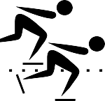 | Listen to Rachmaninov’s  Piano Concerto in c minor. | Perform a piece for someone over the phone! | 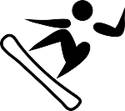  Finish one unit of Sight Reading.
Play your piece with all staccatos! 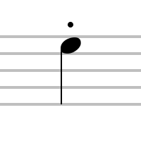 | Compose a piece about your favorite winter sport! | Pass off one technique key. | Listen to the Russian National Anthem. | Play all 5 finger patterns in under one minute.

