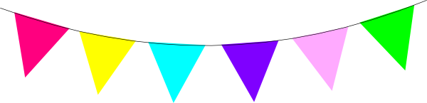

Spring Piano Recital
Title………….…………......………………………………….Composer
Title………….…………......………………………………….Composer
Student

Title………….…………......………………………………….Composer
Title………….…………......………………………………….Composer
Student

Title………….…………......………………………………….Composer
Title………….…………......………………………………….Composer
Student

Title………….…………......………………………………….Composer
Title………….…………......………………………………….Composer
Student

Title………….…………......………………………………….Composer
Title………….…………......………………………………….Composer
Student

Title………….…………......………………………………….Composer
Title………….…………......………………………………….Composer
Student

Title………….…………......………………………………….Composer
Title………….…………......………………………………….Composer
Student

Title………….…………......………………………………….Composer
Title………….…………......………………………………….Composer
Student

Title………….…………......………………………………….Composer
Title………….…………......………………………………….Composer
Student

Title………….…………......………………………………….Composer
Title………….…………......………………………………….Composer
Student

Title………….…………......………………………………….Composer
Title………….…………......………………………………….Composer
Student

Title………….…………......………………………………….Composer
Title………….…………......………………………………….Composer
Student

Title………….…………......………………………………….Composer
Title………….…………......………………………………….Composer
Student

Title………….…………......………………………………….Composer
Title………….…………......………………………………….Composer
Student

Title………….…………......………………………………….Composer
Title………….…………......………………………………….Composer
Student

Title………….…………......………………………………….Composer
Title………….…………......………………………………….Composer
Student

