Lesson Date:____________________
Parent Note to Teacher:
Note to Parents:

Sightreading Assignment:

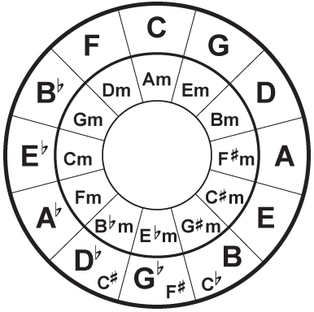
Technique/Warm-ups:

Technique and Sightreading Practice Chart
S | M | T | W | Th | F | St

Assigned Pieces:
Title: | Book: | Page: | Practice Tips/Goals: | I practiced this on…
 |  |  |  | S | M | T | W | Th | F | St

Theory Assignment: Parent Initials:

